**WORK INSTRUCTIONS FOR** **LADLE DESULPHURISATION**

**Responsibility: PCM In charge**

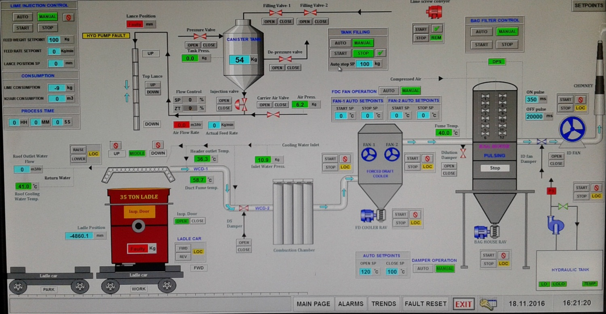

**DS Unit PLC**

**Identified Hazards:**

1. Contact with burnt lime powder
2. Pressure in the N2 line
3. Fall of lime bag
4. Fall of DS ladle cover
5. Impact on overhead cable while shifting the ladle cover
6. Electric shock
7. Contact with lime powder
8. Contact with hot metal & other accessories
9. Fall of metal jam from top
10. Nonuse of PPE/WI
11. Improper house keeping
12. Inadequate local lighting
13. Skin problems due to contact with burnt lime powder
14. Burns due to contact with hot metal
15. Dust generation
16. Fall of DS lance
17. Fall of a person
18. Fall of Cylinders
19. Impact with moving Machinery
20. Cutting of DS Cap sling.
21. ID Tripping during DS operation.
22. Metal Splashing During DS
23. Contact with moving ladle car
24. Fall of ladle during placing on ladle car without radio remote
25. Explosion in exhaust line of dedusting unit during DS
26. Blockages in pathways
27. High water pressure in cooling pipes of hood
28. Abnormal sound of depressurizing valve
29. High noise level in F.D. and I.D. fans.
30. Release of air pressure in hose after DS
31. Opening of powder discharge valve at tank bottom
32. Breaking of lance and falling down
33. ID fan running indication taken on starter, not of VFD

**Do’s:**

1. Ensure pump is running & water flow is at least above 45 m3/hr. Normally flow to be kept between 50-55 m3/hr.
2. Lance cleaning to be done after every heat.
3. Ensure hood is cleaned shift wise handed to reliever in clean condition
4. Ensure Ladle car is cleaned heat wise.
5. Ensure all equipment running sequence is complete and all equipment is in running condition before DS starts.
6. Ensure dust from bags below bag house and below FD cooler are emptied and disposed regularly.
7. Maintain proper housekeeping in the area.
8. Lime tank weight to be maintained at minimum 1.5 t.
9. Lime tank pressure to be maintained as per instructions.
10. Lime dispensing & filling hopper to be emptied before lime tank is full by dispensing.
11. All PPE’s to be used.
12. Lance relief valve to be opened after every DS ladle and to be closed before DS is started.
13. Periodic cleaning of combustion chamber.
14. Periodic inspection of lances for checking sufficiency/condition of refractory material on lance
15. Ensure the condition of lime bags especially above 85% CaO is good for lifting as High CaO bags gets deteriorate quickly.

**Don’ts:**

1. Don’t allow jamming of hood with metal
2. Don’t allow jamming of ladle of car with metal
3. Operation of depressurizing valve during DS operation
4. Horse play
5. Bypassing of sequence Interlocks
6. Changing of set points of critical parameters on PLC
7. Cleaning of the hose pipe/lance in pressurized conditions
8. Standing in front of moving ladle car
9. Touching the hood immediately after DS operation.
10. Ladle car movement when hood is positioned on ladle for DS.
11. Ladle car movement when lance is positioned above metal in ladle
12. Manual butterfly valve in open condition during powder filling in tank.
13. Person to stand below hood when lance is being flushed with air
14. No persons will be allowed to clean the lance hole by positioning below the lance.

**Significant Aspect:**

1. Generation of fumes
2. Emission of lime dust

**Procedure:**

1. Unauthorized operation or repair of any equipment is a punishable offence.
2. Before opening the cast, it should be ensured that the ladles are clean of ring jam as well as bottom jams. In case the ladle has bottom jam; salt is to be added and should be preferably placed at the first metal spout.
3. Open the cast in the first metal spout, by adding at least 2 bags of rice husk divert the metal in the second metal spout, after the ladle in first spout attains hot metal and which is about 75-80 % of the capacity – Responsibility: Furnace in charge

**Responsibility: Desulphurization Engineer**

1.Desulphurization In charge should ensure that all workers / staff connected with the activity are wearing necessary PPE’s viz., safety goggles, dust mask, helmet, hand gloves and safety shoes. Necessary safety pep talk to be given to all the workmen.

2**.** Shift the ladle from the first metal spout to the desulphurization area. Before placing the ladle. On the car

3. Ensure that the lance is clear by either cleaning it well or replacing it. Ensure ladle placed on car is positioned correctly below hood by operating the car winch.

4. New lance to be handled by four persons while replacing by chain pulley or rope

**1). Filling of tank through Lime conveyor system**

**Starting Process:**

1. Check for instrument pressure.

2. Check for the conveyor pressure.

3. Check for the high-level signal of the feed hopper.

4. Check if the switch gate valve is open.

5. Check if the switch gate seal confirm is there.

6. Release the push button located at the D/S area.

7. Start the process by selecting start on the panel. The above seven points are displayed as green LED’s on the panel.

**Stopping process**:

1. Check for the high-level signal of the D/S tank.

2. Press the push button located at the D/S area.

3. Stop the process by selecting stop on the panel.

* DS In charge should ensure that after D/S process push button of knife gate valve above tank is released in order to open the valve and to start the system.
* Lime handling crane to be operated by only trained operators only, before lifting 01-ton jumbo burnt lime bag ensure that all four jumbo bag clips are to be anchored in hook to avoid falling of bag during lifting.
* Operator should operate the crane from safe distance, do not stand below the jumbo bag being carried by the crane.
* Two persons will position the bag at the opening of tank and open the knot and slowly empty the powder by screening in the tank.

In the event of radio remote of 3t crane malfunctioning when any operation is going on and not responding.

1. The crane Operator can stop the crane by operating the “OFF” push button present on the Emergency radio remote. Emergency radio remote has been provided in addition to main remote so that the main power to the EOT crane is stopped and crane operation is thereby stopped.
2. The functioning of Emergency radio remote to be checked by operator in every shift
3. Additional radio remote has been mounted along with the main remote. Both the remote shall be to be maintained together all the time.

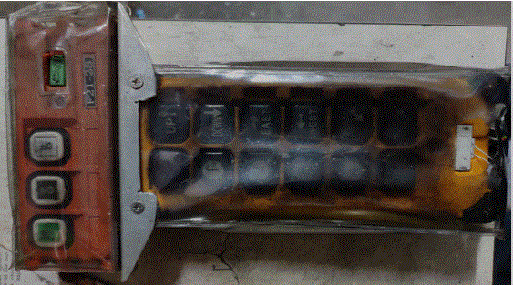

“OFF” button of Emergency radio remote

* If lime transfer line is chocked then relief valve in line is to be opened in order to flush the line, during this activity use of sealed goggle is must.

**2). Desulphurization:**

1.Ensure barricade chain in front of Desulphurization is placed before D/S process.

2.Ensure that the ladle car is not parked in crane bay. Ensure hot metal crane is not parked near

the ladle which is being desulphurized Fill the ladle about 75-80 % of its capacity and place at

the designated spot. Ensure that the ladle is placed in such a way, that the hood sits perfectly

on top of it. Any shift in ladle placement, will result in metal spillage.

3. Cover the 10t trunnion with a metal plate or jam.

4.Lower the lance assembly such that the lance tip is just above the metal level.

1. Ensure that the desulphurization area is free and clear of people and equipment. Lower the hood till it properly fits the ladle.
2. Before staring DS process ensure that the area is properly barricaded.
3. Water cooling pump with about 50m3/hr flow to be started.
4. Start ID from the PLC provided in pouring cabin ID once started baghouse filters, RALs & FD fans 1 & 2 will start in auto.
5. Open the carrier air valve from PLC. Please refer the schematic diagram.
6. Ensure that depressurized line is closed and a pressure of approx. 4 kg/cm2 is maintained in the Lime tank.
7. Open manual air valve (1) which is located before carrier air auto valve.
8. Open manual air valve (2) which is located between lime tank (canister tank) valve & carrier air auto valve & check physically air is flushing through lance (to be done through inspection door on hood) to make sure lance is clear.
9. Open the canister tank manual butterfly valve & check physically powder is flushing through lance (to be done through inspection door on hood).
10. Now lower the lance into the metal slowly after ensuring that there is enough agitation and flow of burnt lime.
11. Do not keep the pressure higher than required, as this will result in unnecessary agitation, leading to metal spillage.
12. Carry on the process till the required quantity of burnt lime (sufficient enough to reduce Sulphur to the desired level) is injected in hot metal.
13. Raise the lance after injecting required amount of burnt lime and then depressurize the tank by opening depressurize valve, once the lance is taken up flush the lance with air and then close the carrier valve.

**Fig.1. sequence of opening of valves in DS unit**

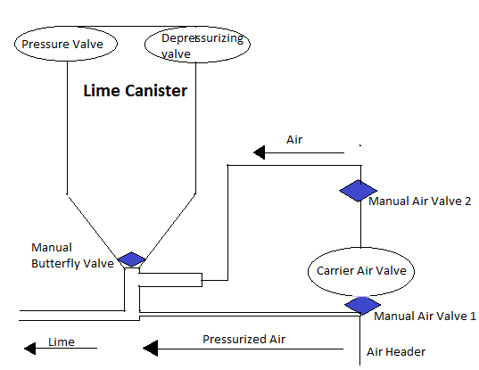

**Fig.2. Schematic diagram of valves in DS unit**

**PLC DISPLAY DESCRIPTION-**

* 1:- Auto start ( Auto or Manual for all motors and pulse valve)
* 2:- Tank filling (Auto or Manual for Canister tank in auto or manual operation)
* 3:- Damper operation (Auto or Manual for Damper)
* 4:- Lime injection control (Auto or Manual for lime injection in auto or manual operation)
* 5:- Manual operation for "ID FAN"
* 6:- Manual operation for "ID FAN DAMPER"
* 7:- Manual operation for "HYDRAULIC PUMP"
* 8:- Manual operation for "FDC FAN-2"
* 9:- Manual operation for " FDC FAN-1"
* 10:- Manual operation for " FDC RAV "
* 11:- Manual operation for "BAG FILTER CONTROL"
* 12:- Manual operation for "BAG HOUSE RAV"
* 13:- Manual operation for "FILLING VALVE-1,2"
* 14:- Manual operation for "DE-PRESSURE VALVE"
* 15:- Manual operation for "CARRIES AIR VALVE"
* 16:- Manual operation for "WATER PUMP"
* 17:- Manual operation for "PRESSURE VALVE"
* 18:- Manual operation for " LANCE"
* 19:- Manual operation for "DS DAMPER"
* 20:- Manual operation for "INSN DOOR"
* 21:- Manual operation for "ROOF "
* 22:- Manual operation for "LIME SCREW CONVYOR"
* 23:- SET POINTS

1. TO RUN THE SYSTEM IN AUTO BELOW INTERLOCK SHOULD BE SATISFY

* All drives, damper, valves, Roof winch, Pump should be in remote selection mode.
* Start water pump from PLC
* To start all the drives, damper & valves in Auto below condition should satisfy.
* Water pump on indication
* Water outlet flow should not be less than the low set point
* If both the above condition satisfies then all the below drives will start
* Id fan ON
* Id fan damper will Open
* Bag house pulsing will Start
* Bag house RAV ON
* FDC fan-1 ON
* FDC fan-2 ON
* FDC RAV ON
* This all motors and pulse valves are operate just click 'START' button of "AUTO START" BLOCK.
* When in "AUTO START" block in 'AUTO' but in 'STOP' condition. That time "LANCE" should be in up position, and 'De-pressure valve' also close.
* If "LANCE" down or middle position that time 'HYDRAULIC PUMP ' automatically start and "LANCE" go to the up position. After "LANCE" in up position 'HYDRAULIC PUMP' automatically stop.
* If 'De-pressure valve' open that will automatically close.

1. When in the display "AUTO START" in 'MANUAL' condition.

* That time all motors and pulse valves are operate manually.

1. When "DAMPER OPERATION" IN 'AUTO' condition.

* There is two set points.
* Open set points - In that temperature 'Dilution Damper' automatically open.
* Close set points - In that temperature 'Dilution Damper' automatically closed.

1. When "DAMPER OPERATION" in 'MANUAL' condition.

That time Damper operate in manually.

**3). Canister tank filing:**

1. Ensure that manual valve of the tank is closed.
2. Open the depressurize valve & make the tank pressure zero.
3. Open both powder filling valve provided above canister tank from PLC.
4. Start the lime dispensing unit.
5. Start screw conveyor after checking the level of hopper.
6. After the desired level is obtained stop screw conveyor along with lime dispensing unit.
7. Close powder filling valve and depressurize valve

When hopper & dispensing unit happen to be made empty and both dispensing unit valves are to be closed after lime powder filling is stopped.

**4). Changing the lance:**

Responsibility: DS In charge, PCM in charge, mech. shift engineer.

i) After the desulphurization process is over, remove the ladle

ii) Ensure that the pouring is not on, on the PCM next to where the desulphurization is

Taking place.

iii) Ensure that the cast is not blowing & the ladles are not being tilted out, during the

Lance changing operation.

iv)Open relief valve provided near the canister tank.

v) Check the lance with a lancing pipe for choke up, if any & the physical condition of lance. If found choked / cracked replace the lance & close the relief valve.

vi)While clearing the castable of the damaged lance, prior to removal, ensure that the

person does not stand directly below the lid, but hits from a distance.

vii) After the lance is replaced, lift the lid assembly to its extreme top position.

**5). Replacing ruptured hose pipes OR clearing choked hose pipes:**

During the process of desulphurization, if the hose pipe gets choked or ruptured follow the procedure given below.

1. Close the Air supply valve.
2. Close the bottom valve of the canister
3. Lift the lid assembly up and open all the relief valves provided in the line.
4. Proceed with the hose changing / clearing job

ANY ACTIVITY IN THE DESULPHURISATION AREA SHALL BE CARRIED OUT ONLY WITH COMPLETE PERSONAL PROTECTIVE GEAR VIZ. SAFETY GOGGLES, SAFETY SHOES, SAFETY HELMET, FULL SLEEVED COTTON SHIRT, HAND GLOVES FACE CLOTH, DUST MASK AND COCONUT OIL APPLICATION TO THE EXPOSED PART OF THE BODY.

PPEs which have been impaired should not be allowed for use and the concerned In-charge should arrange to replace the same.

|  |  |  |
| --- | --- | --- |
| **Prepared By:**  Head – Production PID I | **Reviewed & Issued By:**  Management Representative | **Approved By:**  Head – Pig Iron Division |
| **Signature:** | **Signature:** | **Signature:** |
| **Date: 10.07.2023** | **Date: 10.07.2023** | **Date: 10.07.2023** |

|  |  |  |  |
| --- | --- | --- | --- |
| **Amendment Record** | | | |
| **Revision date** | **Manual Section ref. and para** | **Brief details of revision** | **New Revision No.** |
| 15.07.2022 | Procedure for ladle desulphurization | Point 9, 17 | 13 |
|  |  |  |  |